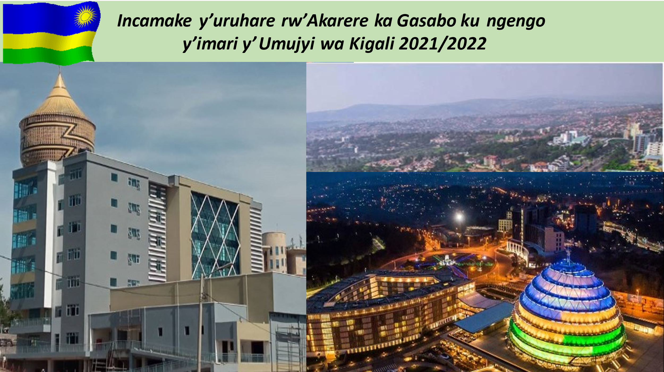

KWAKIRA IBITEKEREZO BY’ABATURAGE BIZINJIZWA MU IGENEMIGAMBI RY’UMUJYI WA KIGALI/2021-2022

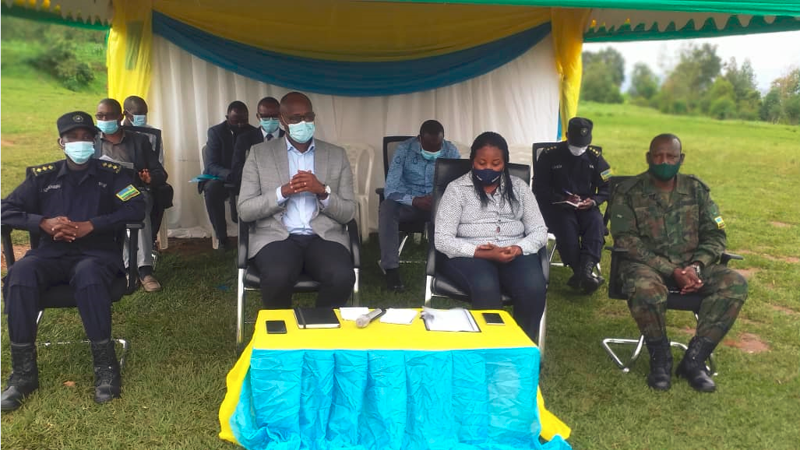

IBIKUBIYEMO
I. IJAMBO RY’IKAZE 3
II.ISHUSHO Y’AKARERE KA GASABO 5
II.1. IMITERERE Y’AKARERE KA GASABO 5
II.2. AMAHIRWE AGARAGARA MU KARERE KA GASABO 7
II.2. 1.UBUCURUZI 7
II.2.2.UBUKERARUGENDO 8
III. IBIPIMO BY’INGENZI BY’AKARERE KA GASABO 9
IV. INGENGO Y’IMARI Y’UMUJYI WA KIGALI 12
IV.1.INGENGO Y’IMARI N’AHO IZATURUKA/ 2021-2022 12
IV.2. UKO INGENGO Y’IMARI ISARANGANYIJE MURI ZA “SECTORS” 13
IV.3. UKO INGENGO Y’IMARI Y’UMUJYI YAGIYE IHINDUKA MU MYAKA 5 (2017-2021) 14
IV.5. IMWE MU MISHINGA IRI MU NGENGO Y’IMARI 2021/2022 IZAKORERWA MU KARERE KA GASABO 16

I. IJAMBO RY’IKAZE
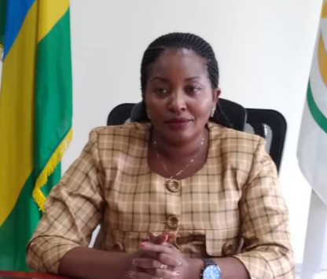

Ndengabaganizi z’Akarere ka Gasabo
Mu izina ry‘Ubuyobozi bw’Akarere ka Gasabo no mu izina ryanjye bwite, Nishimiye kubagezaho agatabo kazabafasha kumenya uruhare rw’Akarere ka Gasabo ku ngengo y’imari y’Umujyi wa Kigali n’imihigo Akarere ka Gasabo kazashyira mu bikorwa mu mwaka w’ingengo y’imari wa 2021/2022.
Intego y’aka gatabo ni ugufasha abaturage kumenya uruhare rw’Akarere ku ngengo y’Imari y’Umujyi wa Kigali n’imihigo y’Akarere bizashyira mu bikorwa kugira ngo buri muturage amenye ibizamukorerwa ndetse abigire ibye afashe ubuyobozi kubishyira mu bikorwa.
Ingengo y’imari y’Umujyi wa Kigali n’imihigo bizafasha mu gushyira mu bikorwa gahunda z’iterambere ry’Igihugu, rigamije impinduka y’imibereho myiza y’umuturage.
Ingengo y’imari y’Umujyi wa Kigali n’imihigo byateguwe hagendewe ku cyerekezo cy’Igihugu (NST1) na gahunda y’Iterambere ry’Umujyi wa Kigali ry’imyaka itandatu (Integreted Development Strategy 2018-2024).

Kumenya ingengo y’imari y’Umujyi wa Kigali n’imihigo bizatuma abaturage barushaho kumenya uruhare rwabo mu itegurwa ryayo, n’uburyo ikoreshwa, kubaza inzego z’ubuyobozi ku ishyirwa mu bikorwa (Accountability)
Imihigo by’umwaka wa 2021/2022 bizashyirwa mu bikorwa hifashishijwe ingengo y’imari igenwa n’Ubuyobozi Bukuru bw’Igihugu (Earmarked transfers), Ingengo y’imari ituruka mu baterankunga (Transfers from other governmrnt Agencies) n’amafaranga Umujyi winjiza mu misoro (Own revenues).
Abaturage, abikorera n’imiryango itegamiye kuri Leta, bazunganira ingengo y’imari hakorwa ibikorwa n’imishinga bigamije iterambere rusange.
Turashimira byimazeyo Abaturage, Inzego za Leta, Abikorera n’Abafatanyabikorwa bose ku ruhare bagize mu gutegura ingengo y’imari n’imihigo by’umwaka wa 2021/2022 n’uruhare bakomeje kugira mu iterambere ry’Akarere ka Gasabo no kuzamura Imibereho y’Abaturage. Turizera tudashidikanya ko ubwo ubufatanye buzarushaho kwiyongera.

UMWALI Pauline
Umuyobozi Nshingwabikorwa w’Akarere ka Gasabo

II.ISHUSHO Y’AKARERE KA GASABO

II.1. IMITERERE Y’AKARERE KA GASABO

Akarere ka Gasabo ni kamwe mu Turere dutatu tugize Umujyi wa Kigali, kagizwe n’Imirenge 15, Utugari 73, Imidugudu 481.
Gaherereye mu burasirazuba bw’Amajyaruguru y’Umujyi wa Kigali
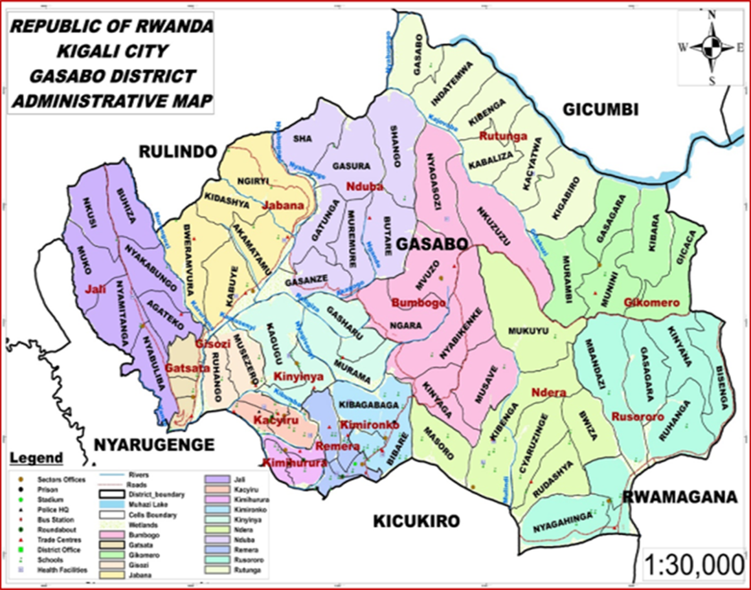
Ikarita y’Akarere ka Gasabo

Akarere ka Gasabo gahana imbibi:
- Mu Majyepfo : Akarere ka Kicukiro
- Mu Majyaruguru : Akarere ka Gicumbi na Rurindo
- Mu burasirazuba : Akarere ka Rwamagana na Gicumbi
- Mu burengerazuba : Akarere ka Nyarugenge
Akarere ka Gasabo gafite:
- Ubuso bungana na Km² 429.2 (= 58.2% bya CoK)
- Abaturage 2012 (NISR) : 529,561 Vs Abaturage 2020 (Ubudehe): 664,742 ( biyongereyeho : 20.3%)
N0 | Umurenge | Umubare w'abaturage /Ibarura rusange 2012 |  |  | Umubare w'abaturage /
N0 | Umurenge |  |  |  | Ubudehe 2020
N0 | Umurenge | Gabo | Gore | Bose | Gabo | Gore | Bose
1 | Bumbogo | 17,722 | 17,659 | 35,381 | 23,504 | 28,291 | 51,795
2 | Gatsata | 19,445 | 17,665 | 37,110 | 22,114 | 20,487 | 42,601
3 | Gikomero | 8,082 | 8,543 | 16,625 | 10,493 | 10,196 | 20,689
4 | Gisozi | 23,209 | 20,794 | 44,003 | 31,048 | 23,873 | 54,921
5 | Jabana | 16,718 | 16,859 | 33,577 | 24,091 | 22,103 | 46,194
6 | Jali | 12,121 | 12,936 | 25,057 | 16,003 | 15,094 | 31,097
7 | Kacyiru | 19,816 | 17,272 | 37,088 | 24,224 | 19,740 | 43,964
8 | Kimihurura | 12,170 | 9,502 | 21,672 | 14,509 | 11,758 | 26,267
9 | Kimironko | 31,881 | 25,549 | 57,430 | 33,929 | 27,203 | 61,132
10 | Kinyinya | 30,320 | 27,526 | 57,846 | 44,895 | 32,081 | 76,976
11 | Ndera | 21,329 | 20,435 | 41,764 | 27,783 | 24,687 | 52,470
12 | Nduba | 12,268 | 13,102 | 25,370 | 22,383 | 18,397 | 40,780
13 | Remera | 23,319 | 19,960 | 43,279 | 24,524 | 20,177 | 44,701
14 | Rusororo | 17,656 | 17,797 | 35,453 | 25,588 | 22,877 | 48,465
15 | Rutunga | 8,490 | 9,416 | 17,906 | 11,278 | 11,412 | 22,690
Bose |  | 274,546 | 255,015 | 529,561 | 356,366 | 308,376 | 664,742

II.2. AMAHIRWE AGARAGARA MU KARERE KA GASABO
Ubukungu bw’akarere ka Gasabo bushingiye kuri ibi bikurikira:

II.2. 1.UBUCURUZI
- Dufite ibigo bigari by’ubucuruzi
- Icyanya k’inganda (Kigali Special Economic Zone)
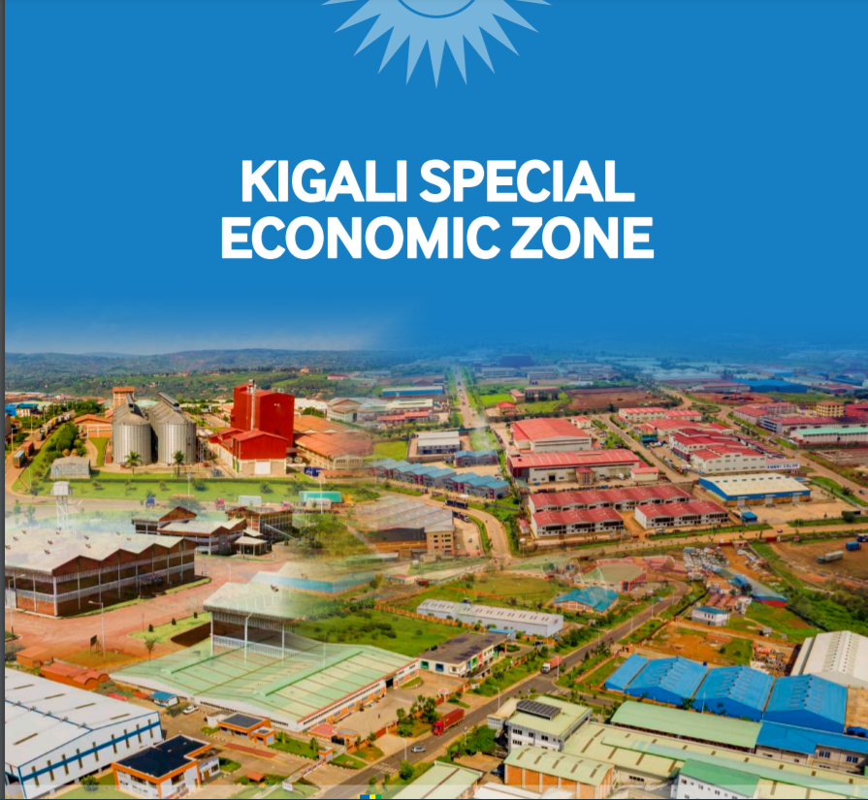

II.2.2.UBUKERARUGENDO
Dufite ibigo by’ubukerarugendo:
- Ibigabiro bya Rwabugiri
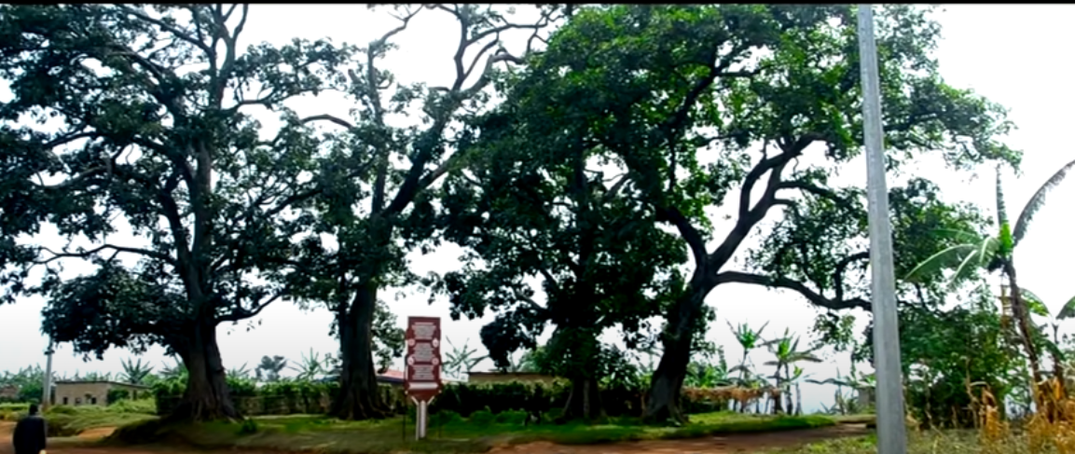
- Bumbogo bwa Nkuzuzu
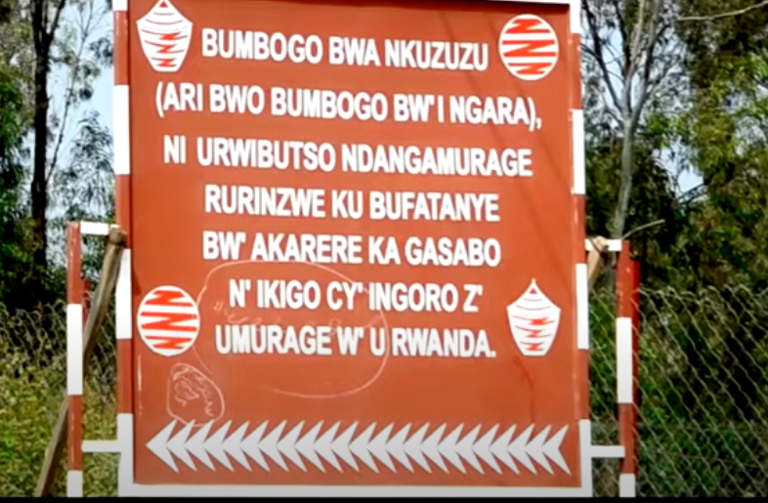

- Ikiyaga cya Muhazi
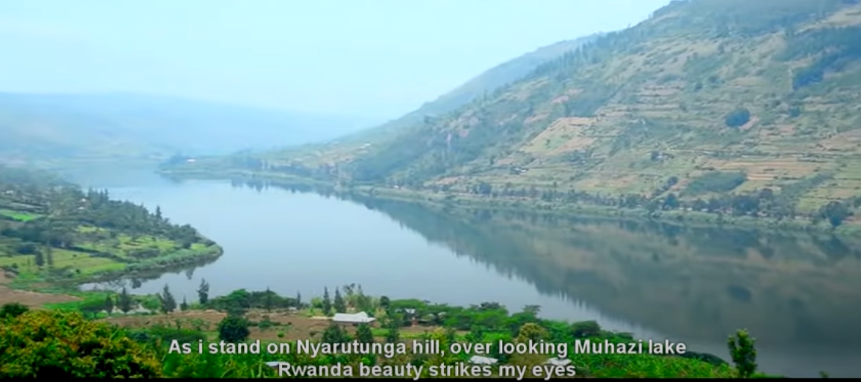
- Nyarutarama Golf Playground
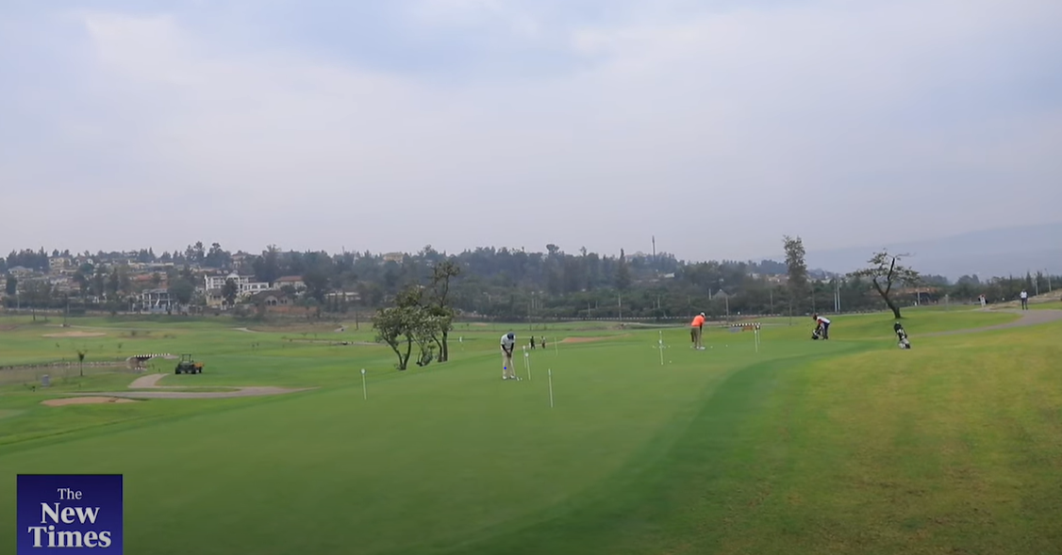
- Ubuhinzi n’ubworozi
- Ubukorikori

III. IBIPIMO BY’INGENZI BY’AKARERE KA GASABO

IBIPIMO (Indicator) | AHO AKARERE KAGEZE/  EICV5 | AHO IGIHUGU KIGEZE/  EICV 5
Ubukene (Poverty Incidence rate) | 15.8% (EICV 5)  Vs 23.4% (EICV4) | 38.2%
Ubukene bukabije (Extreme Poverty rate) | 4.5% (EICV 5)  Vs 11.3% (EICV4) | 16%
Akazi (Labour force participation Rate) | 65.3% (LFS, August 2017) | 52.9%
Ubushomeri (Unemployment rate) | 19.6% (LFS, August 2017) | 17.8%
UBUHINZI (Agriculture)
Ubutaka buhuje (Land under consolidation) | 2.2% (EICV 5) | 15.9%
Ubutaka burwanyijeho isuri (Land protected against soil erosion) | 50.4% (EICV 5) | 68.5%
Ubutaka bwuhirwa (Land under irrigation) | 1.2% (EICV 5) | 6%
INGUFU (Energy)
Imiryango imurikisha amashanyarazi (Households using electricity for lighting) | 74.7% (EICV 5) | 27.1%
UBUREZI (Education)
Abazi gusoma no kwandika (Literacy rate (%) of population aged 15 and above) | 86.2% (EICV5) | 72.9%
Abitabira amashuri abanza (Net Attendance Rate in primary) | 86.4% (EICV5) | 87.7%
Abitabira amashuri yisumbuye (Net Attendance Rate in secondary) | 33% (EICV5) | 24.3%
UBUZIMA (Health)
Abana bagwingiye (Stunted children under five years) | 22% (DHS 5) | 38%
Abaringaniza urubyaro (Married women age 15-49, currently using modern contraception) | 51% (DHS 5) | 48%
ISUKU N’ISUKURA (Water and sanitation)
Ingo zikoresha amazi meza ( Households using an improved water source) | 95.8% (EICV 5) | 87.1%
IKORANABUHANGA (ICT)
Ingo zifite mudasobwa (Households owning a computer) | 9.6% (EICV5) | 3.3%
Ingo zifite telephone ( Households owning a mobile phone) | 85.7% (EICV5) | 66.9%
IBIDUKUKIJE (Environment and Natural resources)
Ingo zifata amazi y’imvura ( Households with rain water catchment systems) | 25.7% (EICV5) | 14.5%
Ingo zitekesha inkwi (Households using firewood for cooking) | 26.2% (EICV5) | 79.9%

IV. INGENGO Y’IMARI Y’UMUJYI WA KIGALI

IV.1.INGENGO Y’IMARI N’AHO IZATURUKA/ 2021-2022

AHO IMARI IZATURUKA (TYPE SOURCES) | 2021/2022 | %
Amafaranga aturuka mu butegetsi bwite bwa Leta / Earmarked Transfers | 45,397,316,739 | 39.3
Amafaranga yinjizwa n’Umujyi/ Own Revenues | 60,511,088,475 | 52.4
Amafaranga aturuka mu bigo bya Leta/ Transfers from other Gvmt Budget Agencies | 7,233,830,786 | 6.3
Amafaranga yimukanywe umwaka/Extra budget | 2,307,690,164 | 2.0
Ingengo y’imari yose /Total Budget | 115,449,926,164 | 100.0

IV.2. UKO INGENGO Y’IMARI ISARANGANYIJE MURI ZA “SECTORS”

N0 | SECTORS | INGENGO Y'IMALI | IJANISHA (%)
1 | Ubwikorezi | 33,852,491,531 | 29.32
2 | Ubuyobozi no gufasha serivisi | 25,254,535,802 | 21.87
3 | Uburezi | 22,722,815,642 | 19.68
4 | Imiturire n’imicungire y’umutaka | 9,269,367,581 | 8.03
5 | Ubuzima | 7,594,102,626 | 6.58
6 | Iterambere ry’imibereho myiza | 5,392,908,125 | 4.67
7 | Ibidukikije n’umutungo kamere | 4,629,347,576 | 4.01
8 | Urubyiruko, siporo n’umuco | 2,382,784,523 | 2.06
9 | Imiyoborere myiza | 1,871,469,246 | 1.62
10 | Iterambere ry’ishoramari n’abikorera | 1,086,552,056 | 0.94
11 | Amazi n’isukura | 681,217,996 | 0.59
12 | Ubuhinzi | 662,333,460 | 0.57
13 | Ingufu | 50,000,000 | 0.04
Ingengo y’imari yose |  | 115,449,926,164 | 100.0

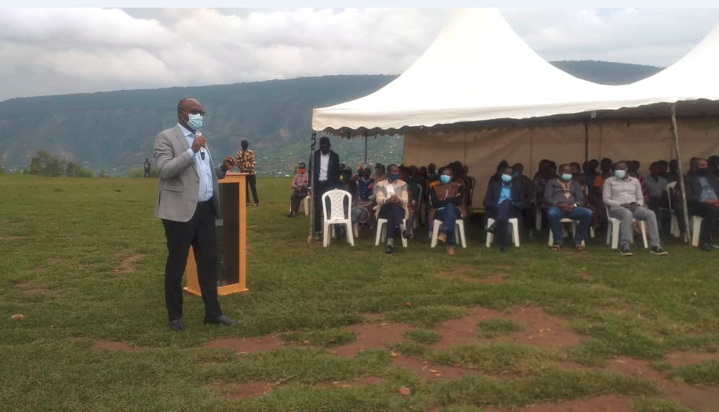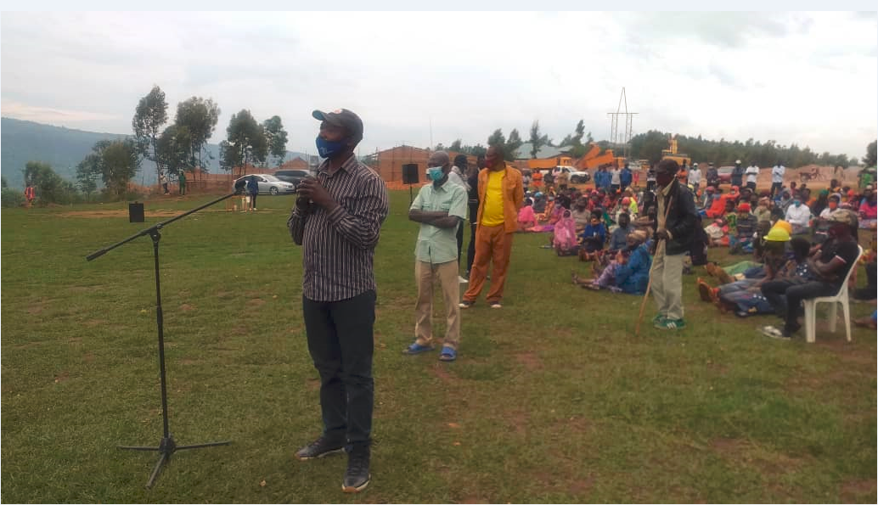
Kwakira ibitekerezo by’abaturage mu Murenge wa Jabana

IV.3. UKO INGENGO Y’IMARI Y’UMUJYI YAGIYE IHINDUKA MU MYAKA 5 (2017-2021)
N0 | UMWAKA | INGENGO Y’IMARI
1 | 2017-2018 | 19,103,614,867
2 | 2018-2019 | 54,180,989,280
3 | 2019-2020 | 124,358,075,478
4 | 2020-2021 | 66,171,055,749
5 | 2021-2022 | 115,449,926,164

IV.4.IMIHIGO Y’UMUJYI IZAKORERWA I GASABO/2021/2022
IMIHIGO YOSE 89

UBUKUNGU | 19
IMIBEREHO MYIZA | 53
IMIYOBORERE | 17

IV.5. IMWE MU MISHINGA IRI MU NGENGO Y’IMARI 2021/2022 IZAKORERWA MU KARERE KA GASABO
N0 | IMISHINGA/IBIKORWA | AHO BIZAKORERWA
 | KURENGERA IBIDUKIKIJE
1 | Hazaterwa ibiti by’amashyamba kuri Ha 10 | Bumbogo  Rusororo
2 | Hazavugururwa Ha 70 z’amaterari y’indinganire anabyazwe umusaruro | Gikomero  Rutunga  Nduba
 | ITERAMBERE RY'ISHORAMARI N'ABIKORERA
1 | Guhanga imirimo mishya ibyara inyungu 14,500 | Imirenge yose
2 | Abajyanama mu bucuruzi bazafasha abagore n’urubyiruko gutegura imishinga 200 isaba inguzanyo muri banki | Imirenge yose
3 | Hazasanwa isoko rusange rya Nyacyonga | Jabana
4 | Hazigishwa urubyiruko rutishoboye 480 imyuga icirirtse | Imirenge yose
5 | Hazatangwa inguzanyo ku baturage 1,091 binyuze muri FS/VUP | Imirenge yose
 | GUTEZA IMBERE UBUHINZI
1 | Hazahuzwa ubutaka hahingwa ibigori kuri Ha 984 | Jabana  Jali  Rutunga  Gikomero  Rusororo  Ndera  Nduba  Bumbogo
2 | Hazahuzwa ubutaka hahingwa ibishyimbo kuri Ha 984
3 | Hazaterwa inkunga abahinzi bafashwa kugura imbuto y’ibigori 39,083 Kg
4 | Hazaterwa inkunga abahinzi bafashwa kugura ifumbire ya DAP 88,838 Kg
5 | Hazaterwa inkunga abahinzi bafashwa kugura ifumbire ya UREA 33,496 Kg
6 | Hazaterwa inkunga abahinzi bafashwa kugura ifumbire ya NKP 39,973 Kg
7 | Hazaterwa inkunga abahinzi bafashwa kugura ifumbire ya KCL +Blends 649 Kg
8 | Ku bufatanye n’abahinzi ba kawa hazasarurwa 50 T za kawa itonoye
3 | Hazahuzwa ubutaka hahingwa umuceri kuri Ha 300 | Jabana  Gikomero  Kinyinya
4 | Hazahuzwa ubutaka hahingwa imboga kuri Ha 843 | Gatsata  Kinyinya  Rusororo  Bumbogo  Nduba
11 | Hakoreshejwe uburyo bugezweho bwo kuhira hakoreshejwe imashini, hazuhirwa 30 Ha | Gatsata  Kinyinya  Rusororo
12 | Hazaterwa intanga inka 3,203 | Jabana  Jali  Rutunga  Gikomero  Rusororo  Ndera  Nduba  Bumbogo
13 | Hazatangwa inka 302 muri gahunda ya Gira inka Munyarwanda
14 | Hazakingirwa amatungo 26,930 indwara z’igifuruto, ubutaka, uburenge n’indwara y’ibisazi by’imbwa n’injangwe. | Imirenge yose
 | UBUZIMA
1 | Abagore batwite nibura 49% bazipimisha kwa muganga inshuro 4 | Imirenge yose
2 | Kuringaniza urubyaro bizitabirwa n’abantu ku kigereranyo nibura cya 59% | Imirenge yose
3 | Ababyeyi bazabyarira kwa muganga ku kigereranyo nibura cya 95% | Imirenge yose
 | UWIKOREZI/TRANSPORT
1 | Hazarangizwa kubakwa umuhanda wa 7km wa kaburimbo Karuruma - Bweramvura | Jabana
2 | Hazubakwa ikiraro k’imigozi cyo mu kirere | Nduba
 | AMAZI ISUKU N’ISUKURA
1 | Hazubakwa umuyoboro w’amazi wa Km 3.5 Kareshya- Bwiza & Mbandazi uzaha ingo nshya 624 | Rusororo
2 | Hazasanwa amavomero 185 atagikora | Jabana  Jali  Rutunga  Gikomero  Rusororo  Ndera  Nduba  Bumbogo
 | ITERAMBERE RY’IMIBEREYO MYIZA
1 | Hazubakirwa imiryango 26 idafite amacumbi | Bumbogo  Nduba  Gikomero  Rutunga  Jali
2 | Hazasanirwa imiryango 260 amazu yangiritse | Bumbogo  Nduba  Gikomero  Rutunga  Jali
3 | Hazasanwa ubwiherero bw’abatishoboye 909 | Bumbogo  Nduba  Gikomero  Rutunga  Jali
4 | Hazubakirwa amacumbi imiryango 55 y’abacitse ku icumu rya Jenoside batishoboye | Rutunga
5 | Hazatangwa akazi ku bantu 1,533 binyuze mu mishinga ya EPW/VUP | Jabana  Jali  Rutunga  Gikomero  Rusororo  Ndera  Nduba  Bumbogo  Gatsata  Gisozi  Kinyinya
6 | Hazatangwa akazi ku bantu 2,942 binyuze mu mishinga ya CPW/VUP | Jabana  Jali  Rutunga  Gikomero  Rusororo  Ndera  Nduba  Bumbogo  Gatsata  Kinyinya

